1) Describe hydrogen bonds, ionic bonds and covalent bonds. Give examples of each.
2) Name the monomers for each macromolecule. Draw generalized structure for each.
3) How is ATP related to a DNA or RNA nucleotide?
4) How does temperature and pH affect the rate of enzymatic reactions? Be specific.
5) Explain how substrate concentration can affect the rate of reaction.
6) Explain how enzyme concentration can affect the rate of reaction.
7) Explain the difference between endergonic and exergonic reactions. What roles does ATP often play in endergonic reactions?
8) Aqueous Carbon dioxide makes solutions acidic. Explain the buffering system that transports CO₂ in the blood.
9) Know your common functional groups. Be able to visually identify them. Be able to associate these functional groups with their respective macromolecules.
10) What is anabolism and catabolism? What role does dehydration synthesis and hydrolysis play in these processes?
11) What is feedback inhibition?
12) What types of bonds are mechanisms for enzyme-substrate binding? Which bond is not a favorable mechanism? Why?
13) What are the functions of the following enzymes: amylase, protease, lipase?
14) Explain the following graph.
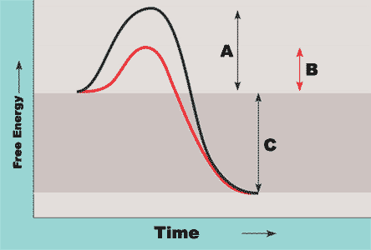
15) Explain the difference between a +ΔG and a –ΔG in terms of anabolic and catabolic reactions.
16) Discuss two environmental factors that can change the rate of an enzyme mediated reaction. How would each affect the reaction rate of an enzyme?
17) Explain the primary, secondary and tertiary structure of proteins. Explain the bonds/interactions involved in each. What role does each bond or interaction play in determining protein structure?
18) How is cell membrane structure an example of the structure/function theme in biology?
19) Discuss five properties of water. How do they contribute to making life possible?
MATH Practice:
Use the formula: C₁V₁=C₂V₂ to solve the following problems.
20) You set up an experiment that requires a final concentration of 0.1M Tris in your tubes with a total volume of 2 ml in each tube. You have a 1 M stock solution in your laboratory. How much of the stock solution will you need in each tube?

21) You are given a solution of amylose-azure at 2 mg/ml. You want your final concentration to be 0.5mg/ml in a 5 ml reaction. How much of the stock amylose-azure solution will you use for that 5 ml reaction?

22) You have a 2 mg/ml stock solution of BSA. You use 0.2 ml of that BSA in a total volume of 1 ml. What is the final concentration of BSA?

Use the rate formula ΔY/ΔX to answer the following questions.
23) Calculate the rate of reaction between 20 and 60 seconds.
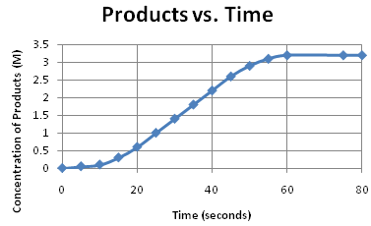
DUE TEST DAY
Reading Guide
Biochemistry Activity
Biochemistry Problem Set
Enzyme Lab

